Designing food for healthy eating

Year 4
Student booklet
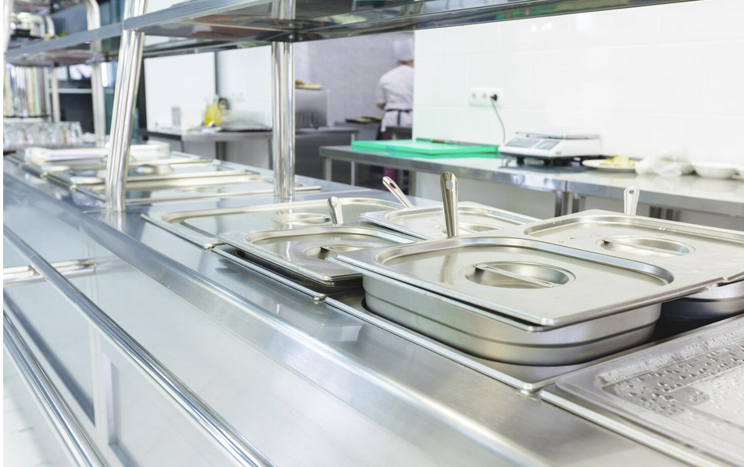

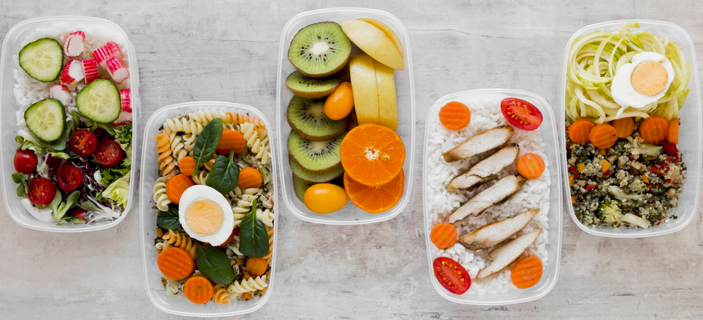

Name: ___________________________________________
Images: Designed by Freepik

Lesson 1: Healthy canteen meal

- Identify a healthy meal for the school canteen.
- Identify 3 reasons why this would make a healthy meal for the school canteen.
- Identify the tools and equipment needed to prepare the meal.

Healthy meal

Reasons why a healthy meal

Tools and equipment to prepare the meal

Lesson 2: Farming methods
Compare farming between Australia and Vietnam
- At least 3 things that are unique to Australia
- At least 3 things that are unique to Vietnam
- At least 3 things that are the same

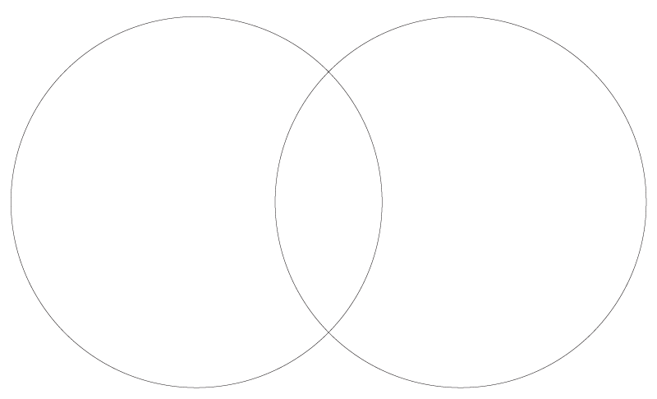
Vietnam
Australia

Lesson 3: First Nations Australians’ food production

A real history of Aboriginal Australians, the first agriculturalists | Bruce Pascoe | TEDxSydney
Take notes as you watch the video

Lesson 3: First Nations Australians’ food production

Key food production techniques of First Nations Australians. What are at least 5 key techniques e.g. burning, tilling, storing, trading?

Provide a summary of each technique.

Lesson 4: Processing for nutrition and food safety

Options: Vacuum sealing, dehydrating, pickling, pasteurising, canning, freezing
Food processing technique
Purpose
Process
Other notes

Lesson 5: Nutrition information

Review the Australian Guide to Healthy Eating. Provide information on the following:
Key information on the AGHE
Health benefits of grain foods
Health benefits of fruit
Health benefits of vegetables

Health benefits of meat and alternative foods
Health benefits of dairy and alternative foods

Lesson 6: Analysing canteen menus

Annotate this canteen menu, with details on: positive aspects; negative aspects. Refer to your knowledge on the principles of the Australian Guide to Healthy Eating to assist with this task.

Extension: Identify the food groups that are in one or more of these items.

Lesson 7: Canteen meal ideas

Meal (name)
Ingredients
Food groups in this meal
Equipment needed for recipe (to prepare and heat)
How one of these ingredients are produced (e.g. high-level steps from farm to supermarket, technologies used)

Other meal options

Meal name | Ingredients

Lesson 9: Summative assessment

Design brief for lunch meal

Task: To design a healthy meal for your school canteen (lunch item). Describe what makes this meal a healthy lunch item.

Format: Describe your healthy meal, which includes listing the ingredients.

Design criteria:

- Include at least 3 of the AGHE food groups.

Note: As this is a hypothetical situation, you can make reasonable assumptions as to what ingredients and equipment are available in the canteen.

Include the following information (such as through annotations or notes):

- identify the food groups that are included
- provide information on how the ingredients are produced (for at least 1 ingredient) (e.g. high-level steps from farm to supermarket, technologies used)
- identify the equipment that is needed for the recipe and their purpose (e.g. a stove, microwave)
- identify the source of your recipe e.g. reference the website or recipe book.
- write a summary that explains why this meal is a healthy lunch item.

Note: the meal does not need to be a hot food item. For example, it can be a wrap or sandwich.

Checklist to assist with this assessment
Design feature | Tick when complete
Healthy meal design (including ingredients)

Information on the food groups that are included

Information on how the ingredients are produced (for at least 1 ingredient)
Information on the equipment that is needed for the recipe and their purpose
Summary that explains why this meal is a healthy lunch item (at least 2 reasons)
Identified the source of the recipe

My healthy canteen meal
Describe your meal, including the ingredients. NOT the meal from lesson 7

Recipe source: _______________________________________________________
Foods groups in this meal (record here or label the description above).

How the ingredients are produced (for at least 1 ingredient)

Equipment item | Purpose

Summary that explains why this meal is a healthy lunch item (at least 2 reasons)

Marking rubric

Criteria | Limited | Partial | Satisfactory | High | Outstanding
Criteria | The student
Lunch meal design (AS1 and AS2) | Produces an outcome where most elements are missing from their lunch meal design | Produces an outcome where some elements are missing from their lunch meal design | Designs a lunch meal that includes 3 food groups  Includes some information on the food groups that are included; how the ingredients are produced; equipment and their purpose; source of the recipe | Designs a lunch meal that includes 4 food groups  Includes clear information on the food groups that are included; how the ingredients are produced; equipment and their purpose; source of the recipe | Designs a lunch meal that includes 5 food groups  Includes detailed information on the food groups that are included; how the ingredients are produced; equipment and their purpose; source of the recipe
Interpreting health information (AS3) | Cannot identify why their meal is a healthy lunch item | Provides minimal explanation of why their meal is a healthy lunch item (e.g. 1 reason or their reasons are incorrect or not clear) | Provides some explanation of why their meal is a healthy lunch item (e.g. 2 reasons) | Provides a clear explanation of why their meal is a healthy lunch item (e.g. 3 reasons) | Provides a detailed explanation of why their meal is a healthy lunch item (e.g. 4+ reasons)

