Strategies to enhance healthy eating

Year 9
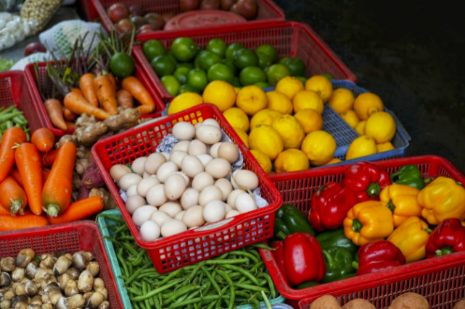

Student booklet

Name: ___________________________________________
Images: Designed by Pexels

Lesson 1: Food group recommendations

Choose a population group from the AGHE categories. Develop a promotional message for this group highlighting their food group needs each day.
Include (as a minimum):
- Number of serves
- Example serve sizes
Be as creative as you like!
Population group:

Lesson 2: Food and nutrient intake data

Choose a population group from the AGHE categories. Using the data sources identified in this lesson, record at least 5 key statistics based on their current food and nutrient intake. Include details on how this compares with the recommendations.

Food and nutrient intake data sources
National Nutrition and Physical Activity Survey: https://www.abs.gov.au/statistics/health/food-and-nutrition/national-nutrition-and-physical-activity-survey/2023
National Health Survey: https://www.abs.gov.au/statistics/health/health-conditions-and-risks/national-health-survey/2022
National Health Measures Survey: https://www.abs.gov.au/statistics/health/health-conditions-and-risks/national-health-measures-survey/2022-24#nutrient-biomarkers
Australia’s health: https://www.aihw.gov.au/reports-data/australias-health/summaries

Population group:

Key statistics:

Lesson 3: Barriers to healthy eating

Barrier to healthy eating:

Strategies for overcoming these barriers (at least 3):

Lesson 4: Critiquing nutrition information

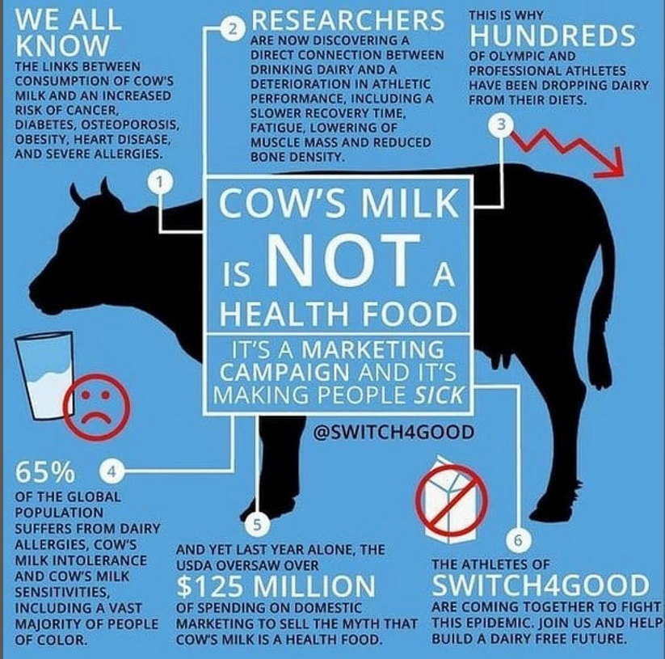
Provide a critique of this infographic considering.
- Does this message vary substantially from the AGHE?
- Who is the author and what are their qualifications?
- Are they trying to sell something?
- Is the evidence based on trusted scientific research?
- Does the information promote extreme eating behaviour?

Lesson 5: Nutrition promotion strategies

Select one nutrition promotion strategy from this lesson.
Research the strategy and identify the potential key benefits in terms of healthy eating.

Lesson 6: Planning a nutrition promotion strategy

Activity (strategy) name:
Target audience:
Activity goals:
Activity details:
Timing and duration of activity:
Resources needed: (This would also include a budget, but just estimate the amount of funds that may be needed)
Who will be involved (stakeholders):
Map out the steps that are needed for the activity to be implemented:

Lesson 7, 8 and 9: Summative assessment

Design brief for healthy eating strategy

Task: To propose and justify 1 key strategy that aims to enhance the nutritional quality of food intake of children and/or adolescents.

Format: Your proposal is to be included within the context of a formal report, which is to include:

- introduction to the issue, that is, provide an overview of the current status on food and nutrient intake of children and/or adolescents (your population group)
- identification of any current barriers to healthy eating in this group
- propose and justify 1 key strategy that aims to enhance the nutritional quality of food intake your population group
- a project plan, comprising a series of steps that are needed for implementation, and the stakeholders that are integral to the success of your proposed strategy.

The project plan can be presented in a separate format to your main report, for example, it could be a video, or PowerPoint presentation, with the aim of ‘selling’ this proposal.

Use the template below, or create your own.

Healthy eating strategy checklist (modify or re-design as needed)

Design criteria | Tick when complete
Introduction to issue (for your chosen population group)

Current barriers to healthy eating in this group

Identify and describe the healthy eating strategy

Identify why this strategy will help enhance the nutritional quality of food intake

Project plan, including a series of steps that are needed for implementation, and the stakeholders that are integral to the success of your proposed strategy

Healthy eating in schools

Introduction

Current barriers to healthy eating

Healthy eating strategy (activity details)

Why this strategy will help enhance the nutritional quality of food intake

Project plan
Activity (strategy) name:
Target audience:
Activity goals:
Activity details:
Timing and duration of activity:
Resources needed: (This would also include a budget, but just estimate the amount of funds that may be needed)
Who will be involved (stakeholders):

Map out the steps that are needed for the activity to be implemented:

Marking rubric
Criteria | Limited | Partial | Satisfactory | High | Outstanding
Criteria | The student
Current status of food and nutrient intake (AS1) | Provides information on the current status of food an nutrient intake that is incorrect/ substantially lacking in detail | Provides minimal information on the current status of food and nutrient intake of their population group (e.g. 1 key piece of data) | Provides some information on the current status of food and nutrient intake of their population group (e.g. 2 key pieces of data)  Provides a basic summary of the key issues | Provides clear information on the current status of food and nutrient intake of their population group (e.g. 3 key pieces of data)  Provides a clear summary of the key issues | Provides detailed information on the current status of food and nutrient intake of their population group (e.g. 4+ key pieces of data)  Provides a detailed summary of the key issues
Current barriers to healthy eating (AS1) | Provides information on the current barriers to healthy eating that is incorrect/ substantially lacking in detail | Provides minimal information on the current barriers to healthy eating in this group (e.g. 1-2 barriers) | Provides some information on the current barriers to healthy eating in this group (e.g. 3 barriers) | Provides clear information on the current barriers to healthy eating in this group (e.g. 4 barriers) | Provides detailed information on the current barriers to healthy eating in this group (e.g. 5+ barriers)
Strategy for enhancing food intake (AS1 and 3) | Proposes 1 strategy that aims to enhance the nutritional quality of food intake in their population group, but provides no justification for why this is an important strategy | Proposes 1 strategy that aims to enhance the nutritional quality of food intake in their population group, and provides minimal justification for why this is an important strategy (e.g. 1 key benefits/ reason why the strategy should be effective OR details are lacking) | Proposes 1 strategy that aims to enhance the nutritional quality of food intake in their population group, and provides some justification for why this is an important strategy (e.g. 2 key benefits/ reasons why the strategy should be effective) | Proposes 1 strategy that aims to enhance the nutritional quality of food intake in their population group, and provides a clear justification for why this is an important strategy (e.g. 3 key benefits/ reasons why the strategy should be effective) | Proposes 1 strategy that aims to enhance the nutritional quality of food intake in their population group, and provides a clear justification for why this is an important strategy (e.g. 4+ key benefits/ reasons why the strategy should be effective)
Design idea (AS2 and 3) | Includes a project plan that lacks most elements in ‘Satisfactory’ | Includes a project plan including:  - Steps for implementation  - Key stakeholders  however, key details are missing | Includes an adequate project plan including:  - Steps for implementation  - Key stakeholders  Some information may be lacking in detail | Includes a clear project plan including:  - Steps for implementation  - Key stakeholders  Adequate information in each area. | Includes a detailed project plan including:  - Steps for implementation  - Key stakeholders  Clear and concise information in each area

