About the five food groups

Foundation
Student booklet
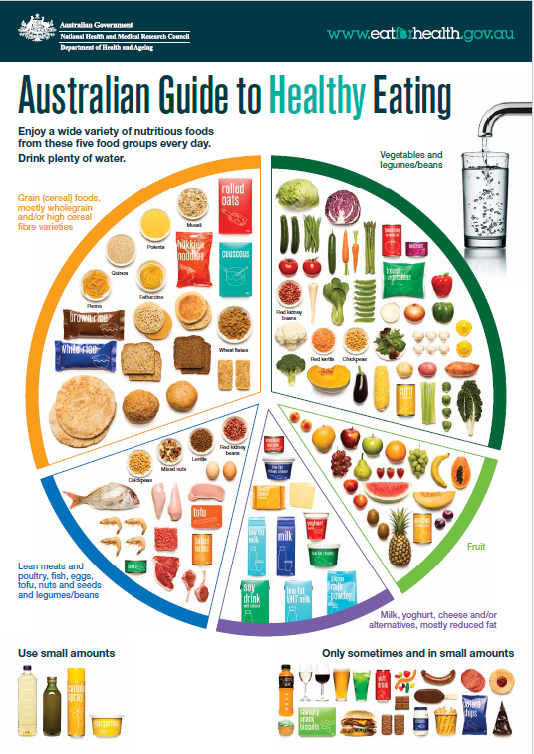

Name: ___________________________________________

Lesson 1: Healthy eating

What do you know about healthy eating? Draw pictures. Write words you know.

Lesson 2: Grain foods

Grain foods are important because (draw or write)
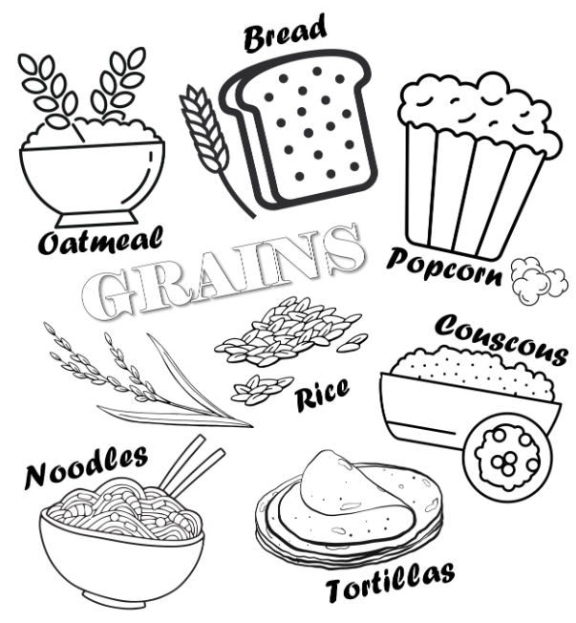
Image source: USDA Agricultural Research Service

Lesson 3: Meat and alternative foods

I like to eat:

Meat and alternative foods are important because (draw or write):

Lesson 4: Fruit

I like to eat:

Fruit is important because (draw or write):

Lesson 5: Vegetables
Types of vegetables
Why vegetables are important

All about vegetables!

Lesson 6: Dairy and alternative foods

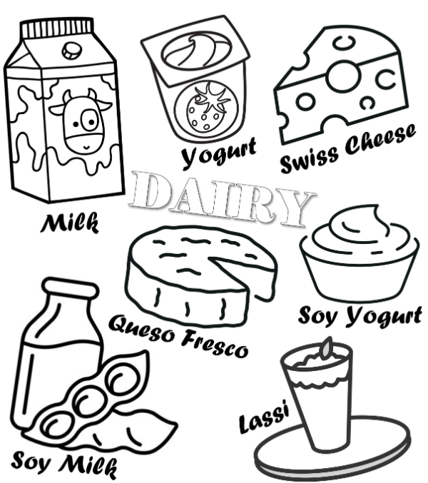
Dairy and alternative foods are important because (draw or write)
Image source: USDA Agricultural Research Service

Lesson 7: Sometimes foods

Swapping sometimes foods

Lesson 9: Summative assessment

- Show the five food groups, with at least 2 foods from each group.
- Show where ‘sometimes’ foods fit.

My Australian Guide to Healthy Eating

The five food groups are important because:

Marking rubric

Criteria | Limited | Partial | Satisfactory | High | Outstanding
Criteria | The student
Communicating food groups (AS1, 2 and 3) | Produces an outcome where most elements are missing from the representation of the five food groups, including sometimes foods and foods within each group | Produces an outcome where some elements are missing from the representation of the five food groups, including sometimes foods and foods within each group | Represents the five food groups, including sometimes foods and foods within each group  e.g.  - 2 food examples  - presentation can be mostly understood | Produces a detailed representation of the five foods groups, including sometimes foods and foods within each group  e.g.  - 3-4 food examples  - clear presentation  AND  some explanation of why food groups are important | Produces a highly detailed representation of the five foods groups, including sometimes foods and foods within each group  e.g.  - 5-6 food examples  - clear presentation  AND  detailed explanation of why food groups are important

