Growing food for healthy eating

Year 6
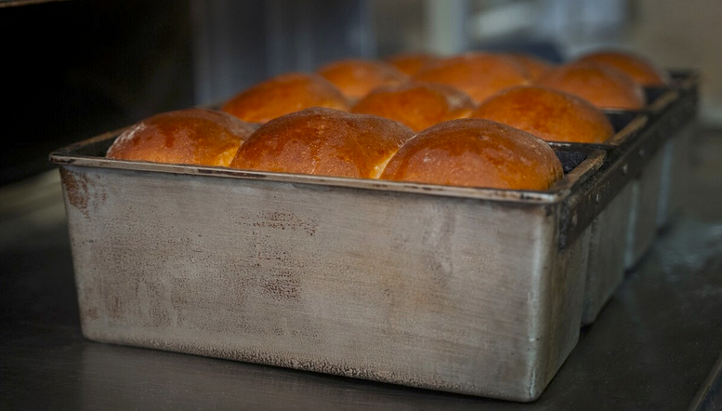
Student booklet
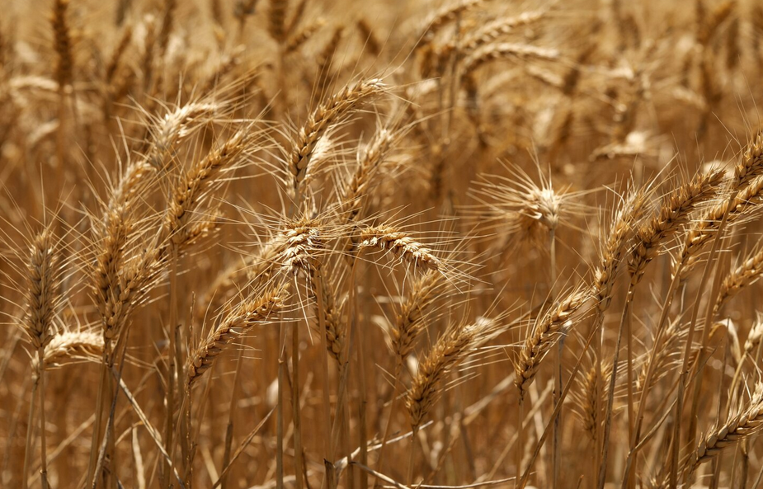
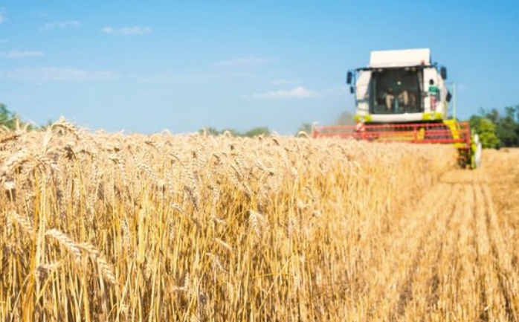

Name: ___________________________________________
Images: Designed by Freepik

Lesson 1: Milk production

Milk from farm to supermarket
Notes from the video (steps at the farm, through transport, at the factory)

Identify the steps on how milk gets from the farm to the supermarket (farm, transport, factory).
Prepare into a flow chart.
Steps at the farm

Transport steps

Steps at the factory

Flow chart: Milk from farm to supermarket (turn to landscape view)

Lesson 2: Food safety at home

What are some of the things you and your family do at home to keep food safe?

What are some things you think you could do better to keep food safe?

Lesson 3: Animal welfare and food production

In relation to the Five Freedoms of animal welfare, identify strategies for farmers to meet these freedoms (what might it look like, sound like)?
- Freedom from hunger and thirst
- Freedom from discomfort
- Freedom from pain, injury and disease
- Freedom to express normal behaviour
- Freedom from fear and distress
For additional guidance, view these videos in relation to feedlot cattle: Freedom 1, Freedom 2, Freedom 3, Freedom 4, Freedom 5
Animal welfare in food production – strategies for farmers (at least 1 in each area)

Lesson 4: Growing food in Australia

Growing rice
Watch the video and take notes on the resources and growing conditions needed for rice production.

Lesson 4: Growing food in Australia

Select an agricultural product. Identify:
- the growing conditions needed to produce the food
- the resources needed to produce the food
- the best location to grow the food in Australia.

Lesson 5: Food production and the environment

Investigate:
- the impact of the environment on farming
- the impact of farming on the environment
- farming practices that aim to overcome/reduce environmental impacts.
What are some of the impacts of the environment on farming?

What are some of the impacts of farming on the environment?

What are some of the farming practices being used to reduce this impact (identify whether the practices are specific to a particular food)?

Lesson 6: Food group nutrition

Food (from the 5 food groups)

Nutritional benefits (at least 5)

References

Lesson 7, 8 and 9: Summative assessment

Growing food for healthy eating

Task: To develop an information report on the production of a food item that assists with healthy eating.

Format: You have the choice of how to present your information report e.g. written, Word, PowerPoint.

Criteria: Your food item must be a core food within the Australian Guide to Healthy Eating (or a combination of core foods).

Include the following information:
- Introduction (about the food)
- How produced, including the steps that take a food from the farm to the supermarket, also presented as a flow chart.
- Food safety considerations– on farm, through transport, in factory.
- Impacts on production–animal welfare, environment
- Growing conditions (areas is suitable for growing/rearing the food)
- The nutritional benefits of the food, within the context of the Australian Guide to Healthy Eating.
- Recommendations on how to eat this food within the context of a healthy diet.
- List of references

Use the template below, or create your own.

Information report checklist (modify or re-design as needed)

Information report | Tick when complete
The information report must include:
Food selected is a core food within the AGHE (or a combination)
Introduction

How produced, including flow chart

Food safety considerations

Impacts on production

Growing conditions

Nutritional benefits of the food

Recommendations on how to eat food within a healthy diet
List of references

Growing food for healthy eating

Food:

Introduction

Food production

Food safety

Impacts on production

Growing conditions

Nutritional benefits

Eating this food within a healthy diet

References:

Marking rubric

Criteria | Limited | Partial | Satisfactory | High | Outstanding
Criteria | The student
Food production (AS1 and AS2) | Selects a food that is not a core food within the Australian Guide to Healthy Eating  Most elements are missing from their information report | Selects a food that is not a core food within the Australian Guide to Healthy Eating  Some elements are missing from their information report | Selects a food that is a core food within the Australian Guide to Healthy Eating  Includes a basic overview of how food is produced (including flow chart), food safety considerations, impacts on production, growing conditions (e.g. 1 piece of information in each area) | Selects a food that is a core food within the Australian Guide to Healthy Eating  Includes a clear overview of how food is produced (including flow chart), food safety considerations, impacts on production, growing conditions (e.g. 2 pieces of information in each area) | Selects a food that is a core food within the Australian Guide to Healthy Eating  Includes a detailed overview of how food is produced (including flow chart), food safety considerations, impacts on production, growing conditions (e.g. 3+ pieces of information in each area)
Analysing health information (AS3) | Cannot identify the nutritional benefits of the food  Cannot identify how this food fits within the context of a healthy diet | Provides minimal explanation of the nutritional benefits of the food (e.g. 1 reason or their reasons are incorrect or not clear)  Provides minimal explanation of how this food fits within the context of a healthy diet | Provides some explanation of the nutritional benefits of the food (e.g. 2 reasons)  Provides some explanation of how this food fits within the context of a healthy diet | Provides a clear explanation of the nutritional benefits of the food (e.g. 3 reasons)  Provides a clear explanation of how this food fits within the context of a healthy diet | Provides a detailed explanation of the nutritional benefits of the food (e.g. 4+ reasons)  Provides a detailed explanation of how this food fits within the context of a healthy diet

