Promoting healthy eating

Year 7
Student booklet

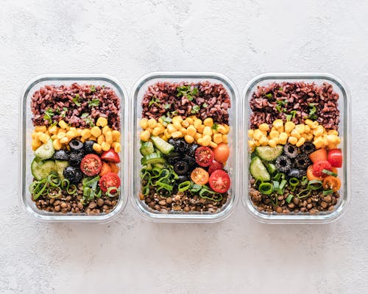

Name: ___________________________________________
Image: Designed by Pexels

Lesson 1: Nutrition advertising

Review current nutrition advertisements or promotional material. Record information from each of these.
Promotional strategies used. Does this appeal to the audience?

Key messages

Credibility of information (think about the author)

Advertising mediums e.g. video, infographic, You Tube short.

Lesson 2: Nutrition across the life stages

Select a population group (age and gender) and summarise their nutritional needs.
- Five food group recommendations
- Types of foods
- Benefits of these foods
- Specific nutrient needs
Select the format and medium in which to present your work.

Population group:

Lesson 3: Food labelling

Product 1
Nutritional quality of product–using the Nutrition Information Panel, Health Star Rating
Is it a nutritious food choice?

Could the nutritional quality be improved? If yes, how?
Types of claims (nutrition/ health claims)
Images to appeal to consumers
Other interesting label information

Product 2
Nutritional quality of product–using the Nutrition Information Panel, Health Star Rating
Is it a nutritious food choice?

Could the nutritional quality be improved? If yes, how?
Types of claims (nutrition/ health claims)
Images to appeal to consumers
Other interesting label information

Product 3
Nutritional quality of product–using the Nutrition Information Panel, Health Star Rating
Is it a nutritious food choice?
Could the nutritional quality be improved? If yes, how?
Types of claims (nutrition/ health claims)
Images to appeal to consumers
Other interesting label information

Lesson 4: Managing food allergies

Identify at least 4 strategies for managing allergies in each of these environments:
• Eating out • Schools • School camps • Feeding family/ friends with allergies
Eating out

Schools

School camps

Feeding family/ friends with allergies

Lesson 5: Reviewing nutrition information

A popular diet that has been promoted is the Paleo diet. The general principles are described in the infographic below. Further details are in this article (noting that no specific author is specified). Additional information is available here.
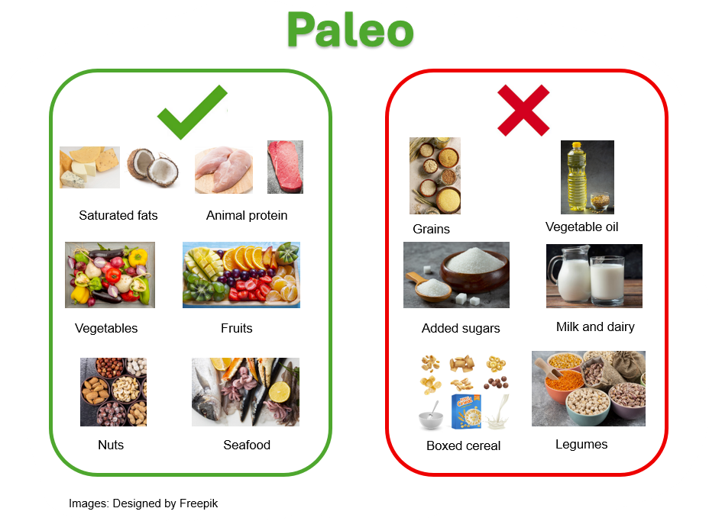
Based on what you know about trusted nutrition information, provide a critique of the Paleo diet, based on the prompts below.
The following information may offer assistance for your review:
Dietitians Association of Australia review
TEDx Talks: Debunking the paleo diet [22.18]

Paleo diet
Positive aspects of this diet
Negative aspects of this diet
Describe any supporting evidence for the health benefits paleo diet

Is the paleo diet supported by university qualified nutrition professionals (e.g. Accredited Practicing Dietitians or Registered Nutritionists)?

Lesson 6: Food and nutrition data
Identify at least 5 key food and nutrition statistics from 3 food and nutrition data sources

Food and nutrition data sources
Eat for health: https://www.eatforhealth.gov.au/
National Nutrition Survey: https://www.abs.gov.au/statistics/health/food-and-nutrition/national-nutrition-and-physical-activity-survey/2023
National Health Survey: https://www.abs.gov.au/statistics/health/health-conditions-and-risks/national-health-survey/2022
National Health Measures Survey: https://www.abs.gov.au/statistics/health/health-conditions-and-risks/national-health-measures-survey/2022-24#nutrient-biomarkers
Australia’s health 2024: https://www.aihw.gov.au/reports-data/australias-health/summaries
CSIRO Healthy Diet Score: https://www.csiro.au/en/research/health-medical/diets/csiro-healthy-diet-score

Food and nutrition data source (1):

Key information/statistics (at least 5):

Food and nutrition data source (2):

Key information/statistics (at least 5):

Food and nutrition data source (3):

Key information/statistics (at least 5):

Lesson 7, 8 and 9: Summative assessment

Design brief for nutrition promotion advertisement

Task: To design a nutrition promotion advertisement that aims to encourage healthy eating in one or more areas. Explain the strategy for your promotion piece and how it aims to influence behaviours around healthy eating.

Format: You have the choice of how to present your nutrition advertisement piece e.g. PowerPoint, infographic (one or more for a campaign), video (such as for YouTube shorts), poster, audio.

You need to:

- Develop the criteria that will guide the development of your nutrition promotion advertisement, which must include:
  - target audience (e.g. teens, young females, parents, people with food allergies/ intolerances, early years)
  - key message/s
  - where the nutrition promotion advertisement will be displayed e.g. poster for school, online (such as You Tube shorts), website
  - overall style for the advertisement.

- Develop the nutrition promotion advertisement that aligns with these criteria.

- Explain the strategy for your advertisement and how it aims to influence behaviours around healthy eating.

- Evaluate your nutrition promotion advertisement against the design criteria, that is, does it meet all the criteria? If not, why did the design change?

Design criteria template (modify or re-design as needed)

Design criteria | Tick when complete
The nutrition promotion advertisement must include/ address:

My advertisement aims to influence behaviours around healthy eating by:

My advertisement meets the design criteria because:

Marking rubric
Criteria | Limited | Partial | Satisfactory | High | Outstanding
Criteria | The student
Design criteria (AS1 and 3) | Develops design criteria that lacks most elements in ‘Satisfactory’ | Develops design criteria that includes:  - Target audience  - Key message/s  - Place that advertisement will be displayed  - Overall style  however, some detail is missing | Develops suitable design criteria that includes:  - Target audience  - Key message/s  - Place that advertisement will be displayed  - Overall style | Develops suitable design criteria that includes:  - Target audience  - Key message/s  - Place that advertisement will be displayed  - Overall style  - 1-2 other design components | Develops suitable design criteria that includes:  - Target audience  - Key message/s  - Place that advertisement will be displayed  - Overall style  - 3-4 other design components
Health promotion advertisement (AS1 and 2) | Develops a nutrition promotion advertisement, where most elements are missing | Develops a nutrition promotion advertisement, with some missing elements | Develops a nutrition promotion advertisement that:  - Aligns with their design criteria  - Is mostly clear in messaging and presentation | Develops a nutrition promotion advertisement that:  - Aligns with their design criteria  - Is clear in messaging and presentation | Develops a nutrition promotion advertisement that:  - Aligns with their design criteria  - Is very clear in messaging and presentation
How advertisement aims to influence behaviours (AS1) | Cannot identify how their advertisement will help influence behaviours around health eating | Provides minimal explanation of how their advertisement will help influence behaviours around healthy eating (e.g. 1 example or examples are not clear) | Provides some explanation of how their advertisement will help influence behaviours around healthy eating (e.g. 2 examples) | Provides a clear explanation of how their advertisement will help influence behaviours around healthy eating (e.g. 3 examples) | Provides a detailed explanation of how their advertisement will help influence behaviours around healthy eating (e.g. 4+ examples)
Design criteria evaluation (AS3) | Cannot identify how their advertisement meets the design criteria | Provides minimal detail on how their advertisement meets the design criteria | Provides a brief overview of how their advertisement meets the design criteria (e.g. basic detail and/or annotations) | Provides a clear overview of how their advertisement meets the design criteria (e.g. detailed annotations or information addressing each of the design criteria) | Provides a detailed overview of how their advertisement meets the design criteria (e.g. highly detailed annotations or information addressing each of the design criteria)

