How to use healthy eating guidelines

Year 1
Student booklet
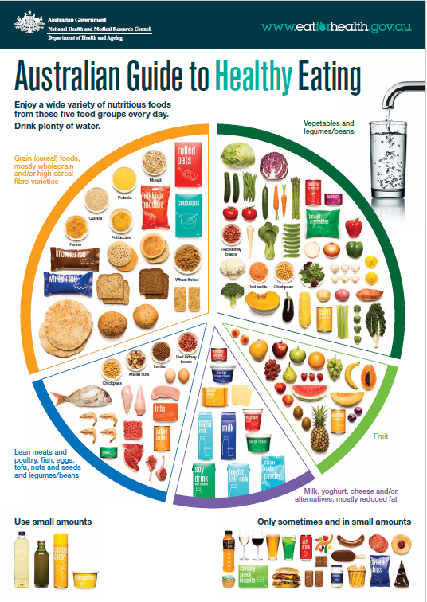

Name: ___________________________________________

Lesson 1: Healthy eating

What do you know about healthy eating? Draw pictures. Write words you know.

Lesson 2: Foods for health

How are the foods in the food groups good for our bodies? Draw pictures. Write words you know.

Lesson 3: Food serves
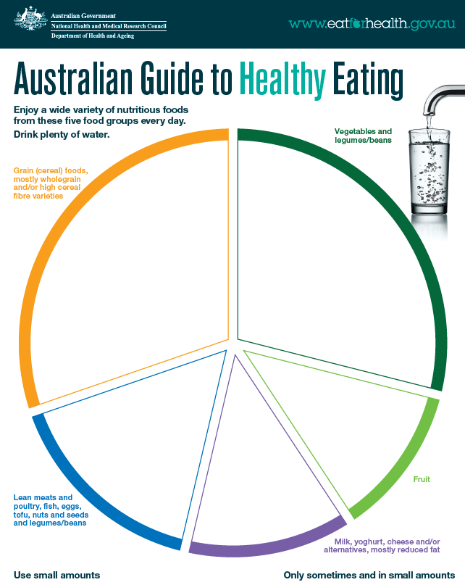
Based on material provided by the National Health and Medical Research Council (representing the Commonwealth of Australia)
2 serves boys
1½ serves girls
1½ serves
4½ serves
4½ serves
1½ serves

Lesson 4: Food group serve sizes

Draw at least 2 items from each food group and write their serve size.
Grain foods

Vegetables

Fruit

Dairy and alternatives

Meat and alternatives

Meat and alternative foods are important because (draw or write)

Lesson 5: Drawing and labelling foods

Draw a food from the five food groups. Label the parts of the image.
Why is this food important?

Lesson 6: Health information

Make a poster to encourage people to be healthy. Include pictures and words.

Lesson 8: Summative assessment

- Represent the five food groups
- Draw and label your food choices in each group based on recommended serves and serve sizes
My daily Five Food Group serves

My five food groups choices are important to my body because:

Marking rubric

Criteria | Limited | Partial | Satisfactory | High | Outstanding
Criteria | The student
Representing the five food groups and serve selections (AS1, 2 and 3) | Produces an outcome where most elements are missing from the representation of their five food group choices | Produces an outcome where some elements are missing from the representation of their five food group choices | Represents their five food group choices, through including the following:  - appropriate foods (or mostly)  - labelling of serve size (or mostly)  - attempts to represent recommended daily serves  - mostly clear drawing and labelling | Represents their five food group choices with detail, through including the following:  - appropriate foods  - labelling of serve size  - represents recommended daily serves  - clear drawing and labelling | Succinctly represents their five food group choices, through including the following:  - appropriate foods  - labelling of serve size  - represents recommended daily serves  - very clear drawing and labelling
Food group choices (AS 1) | Cannot identify why food groups are important | Provides minimal explanation of why food groups are important (e.g. 1 example or examples are not clear). | Provides some explanation of why food groups are important (e.g. 2-3 examples) | Provides a clear explanation of why food groups are important (e.g. 4-5 examples) | Provides a detailed explanation of why food groups are important (e.g. 6-7 examples)

