Developing food for the environment and healthy eating

Year 8
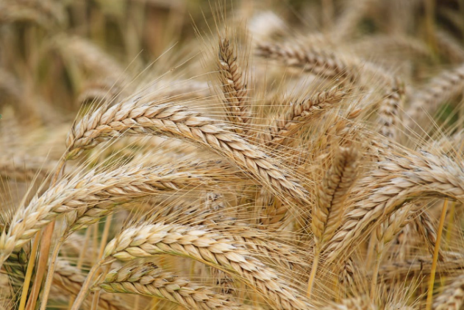
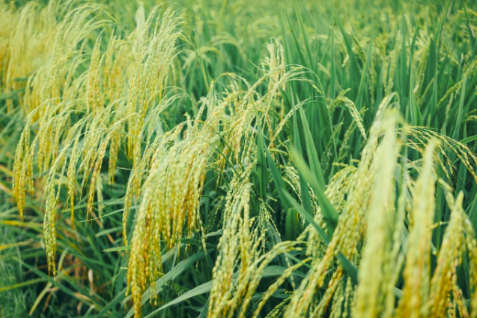
Student booklet
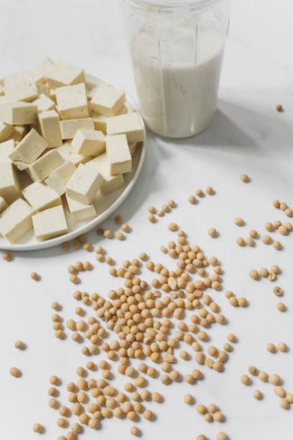

Name: ___________________________________________
Images: Designed by Pexels

Lesson 1: Food production in Australia

Using the report Snapshot of Australian Agriculture 2025, ABARES (2025), identify 10 key pieces of data/ information that you found most interesting in relation to the agriculture in Australia (from across the report). Resource available here (pdf version also available).
10 interesting pieces of data/ information related to agriculture in Australia

Lesson 2: Food production and the environment

Using the resources:
Climate change impacts and adaptation on Australian farms
State of the climate 2024
Conversation article

Identify 3 key pieces of information in each of the following areas:
Changes in seasonal conditions in Australia

Impact on farmers of these changes in seasonal conditions

How farmers are adapting
Other notes

Lesson 3: Forming a healthy diet

Food group | Number of serves I need each day | My food choices, including serve size
Grain foods
Fruit
Vegetables

Food group | Number of serves I need each day | My food choices, including serve size
Meat and alternative foods
Dairy and alternative foods

Lesson 4: Consumer needs

What are the factors that influence the selection of foods in your family? Identify at last 3 factors.
What foods do you purchase to help meet the needs of your family. Try to consider foods that help your family adhere to the Australian Guide to Healthy Eating.
Factors that influence the selection of foods in my family (at least 3)

Foods that help meet these needs.

Lesson 5: New food developments

Create a poster that promotes either lab grown meat (cell-cultured meat), or edible insects. Include the following aspects:
- Nutritional benefits
- Environmental benefits
- Consumer benefits

Lesson 6: Food and nutrition data
Identify at least 3 key facts for each of the five food groups

Data sources
Food Standards Australia New Zealand
Australian Institute of Health and Welfare
National Health and Medical Research Council
Department of Health, Disability and Ageing
Dietitians Australia
Nutrition Australia
Dairy Australia
Grains & Legumes Nutrition Council
Veggycation
Good Meat
Sanitarium

Grain foods:
Key facts:

Fruit:
Key facts:

Vegetables:
Key facts:

Meat and alternative foods:
Key facts:

Dairy and alternative foods:
Key facts:

Lesson 7, 8 and 9: Summative assessment

Using technologies for healthy eating

Task: To develop an information text on a food product that aims to assist with addressing environmental issues and enhance healthy eating.

The food product is to be something that has been developed or is currently in development.

Format: You have the choice of how to present your information text e.g. written, poster, Word, PowerPoint. It does not need to be a text heavy piece, and be sure to include images to complement and support your arguments.

Criteria: Your food item must be considered a core food within the Australian Guide to Healthy Eating (or a combination of core foods).

Include the following information:
- Introduction (about the food product).
- How produced, including the steps that take the food from the beginning of development to the supermarket, also presented as a flow chart. This is to include the technologies used.
- The role of the food within the context of Australia’s food and nutrition system.
- How the food is important to assist with healthy eating (e.g. how does it help consumers follow a diet that aligns with the Australian Guide to Healthy Eating?).
- How the food will benefit the environment.
- How the food will benefit the consumer (beyond nutrition e.g. convenience, food safety).
- List of references.

Use the template below, or create your own.

Information text checklist (modify or re-design as needed)

Criteria | Tick when complete
The information text must include:
Food selected is a core food within the AGHE (or a combination)
Introduction

How produced, including flow chart. Include details on technologies used.
Role of the food within the context of the Australian food and nutrition system
How the food is important to assist with health eating

How the food will benefit the environment

How the food will benefit the consumer

List of references

Using technologies for healthy eating

Food:

Introduction

Food production (flow chart, technologies)

Role of the food within the context of the Australian food and nutrition system

How the food is important to assist with health eating

How the food will benefit the environment

How the food will benefit the consumer

References:

Marking rubric
Criteria | Limited | Partial | Satisfactory | High | Outstanding
Criteria | The student
Food production (AS1 and AS2) | Selects and food that is not a core food within the Australian Guide to Healthy Eating  Most elements are missing from their information report | Selects a food that is not a core food within the Australian Guide to Healthy Eating  Some elements are missing from their persuasive text  Images provide little support to the persuasive text | Selects a food that is a core food within the Australian Guide to Healthy Eating  Includes a basic overview of how food is produced (including flow chart), food and nutrition system information, benefits to the environment, benefits to the consumer (e.g. 1 piece of information in each area)  Information on the technologies used is provided, yet lacking in detail  Images provide some support to the persuasive text | Selects a food that is a core food within the Australian Guide to Healthy Eating  Includes a clear overview of how food is produced (including flow chart food and nutrition system information, benefits to the environment, benefits to the consumer (e.g. 2 pieces of information in each area)  Includes information on the technologies used  Uses images that clearly support the persuasive text | Selects a food that is a core food within the Australian Guide to Healthy Eating  Includes a detailed overview of how food is produced (including flow chart), food and nutrition system information, benefits to the environment, benefits to the consumer (e.g. 3+ pieces of information in each area)  Includes detailed information on the technologies used  Uses images that provide strong support to the persuasive text
Analysing health information (AS3) | Cannot identify the nutritional benefits of the food | Provides minimal explanation of the nutritional benefits of the food (e.g. 1 reason or their reasons are incorrect or not clear) | Provides some explanation of how the food is important to assist with healthy eating (e.g. 2 reasons) | Provides a clear explanation how the food is important to assist with healthy eating (e.g. 3 reasons) | Provides a detailed explanation of how the food is important to assist with healthy eating (e.g. 4+ reasons)

