Designing a daily meal plan

Year 5
Student booklet

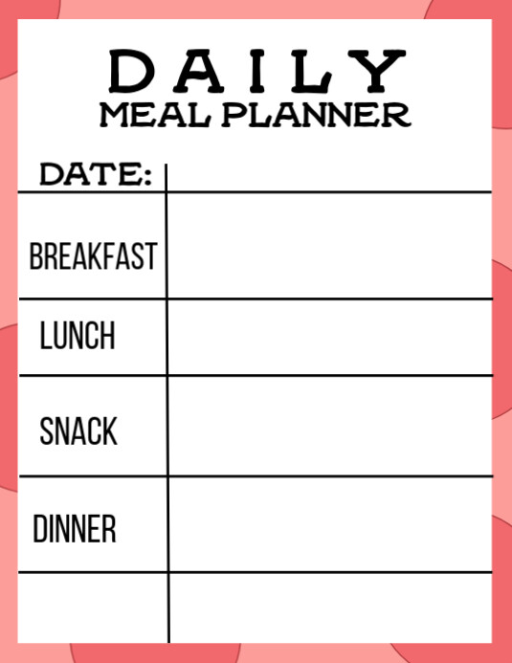

Name: ___________________________________________

Lesson 1: The Australian Guide to Healthy Eating

- What do you know about the five food groups (through the Australian Guide to Healthy Eating)?
- What do you know about food group serve recommendations?
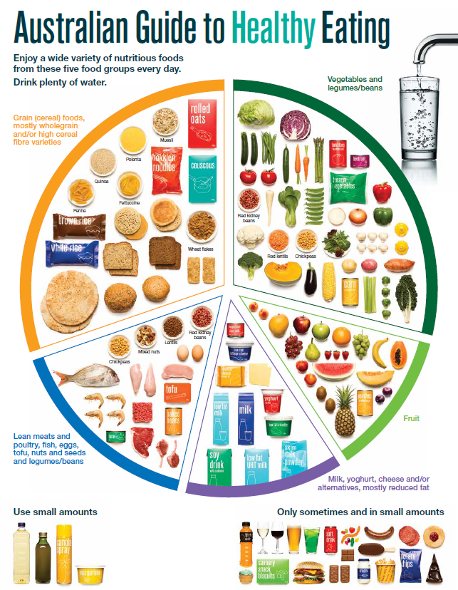
Source: National Health and Medical Research Council (representing the Commonwealth of Australia)
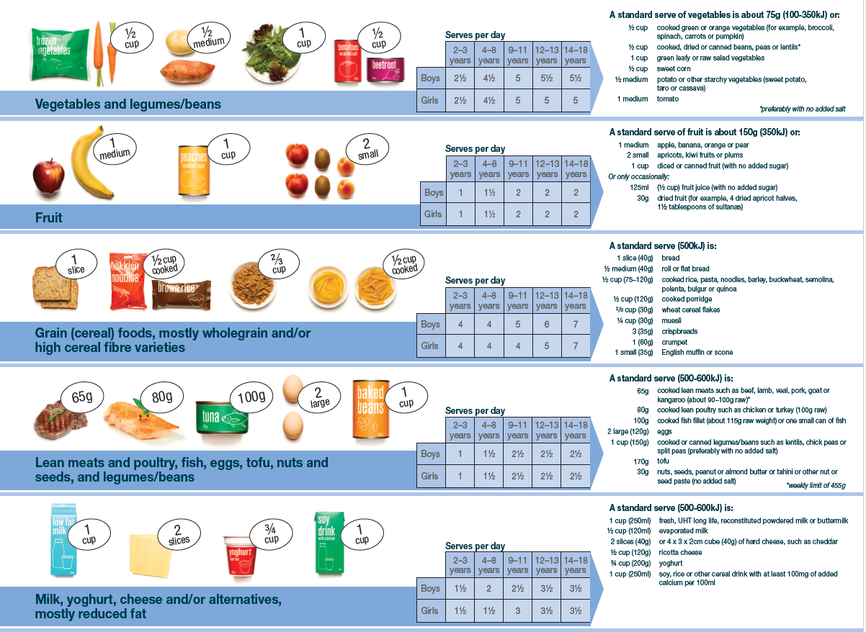
Source: National Health and Medical Research Council (representing the Commonwealth of Australia)

Task: Record everything you know about these documents, including how they can be used to guide our daily food choices.

Lesson 2: Healthy eating

Using the Australian Dietary Guidelines brochure, identify key information:

Overall guidelines to healthy eating

Food groups, serves

‘Sometimes’ foods (discretionary foods)

Lesson 4: Recipe analysis and modification

Recipe name
Number of serves
Ingredients

Identify the serves of each food group in the recipe (use info on page 3 to assist)
 | Vegetables | Fruit | Grain foods | Meat and alternatives | Dairy and alternatives | Sometimes foods
Serves per recipe
Serves per person

What food groups are missing or low in quantity?
Does the recipe contain too many serves of ‘sometimes’ foods?

How could you modify the recipe to:
- Increase the servings of foods from the 5 food groups?
- Enhance the nutritional quality of ingredients e.g. wholegrain cereals?
This could include adding additional items to serve with the recipe.

Lesson 5: Daily meal plan design ideas

Meal plan layout and content ideas

Lesson 6: Meal plan design criteria
- At least 5 criteria for daily meal plans
- Reference to the ADGs/ AGHE

List some criteria that can be used to guide the development of a daily meal plan (group work)

Lesson 7: Daily meal plan
- Meets design criteria (from lesson 6)

Daily meal plan (group work)
Meal | Foods | Food groups
Breakfast
Snack
Lunch
Snack
Dinner
Snack

 | Vegetables | Fruit | Grain foods | Meat and alternatives | Dairy and alternatives
Serves

Lesson 8 and 9: Summative assessment

Design brief for meal plan design

Task: To design a daily meal plan. Explain how your meal plan will help support health and wellbeing.

Format: You have the choice of how to present your meal plan e.g. written, poster, Excel, Word, PowerPoint.

You need to:

- Develop the criteria that will guide your meal plan, which must include:
  - Reference to the Australian Dietary Guidelines/ Australian Guide to Healthy Eating, including daily recommended serves
  - Breakfast, lunch, dinner, snacks

- Design a daily meal plan that aligns with the design criteria.

- Describe the key features (label your meal plan).

- Explain how your meal plan will help support health and wellbeing.

- Provide an assessment of how the meal plan meets the design criteria.

Design criteria template (modify or re-design as needed)

Design criteria | Tick when complete
The meal plan must include:

Daily meal plan
Meal | Foods | Food groups
Breakfast
Snack
Lunch
Snack
Dinner
Snack

 | Vegetables | Fruit | Grain foods | Meat and alternatives | Dairy and alternatives
Serves

My meal plan helps support health and wellbeing by:

My meal plan meets the design criteria because:

Marking rubric
Criteria | Limited | Partial | Satisfactory | High | Outstanding
Criteria | The student
Design criteria (AS 1 and 3) | Develops design criteria that lacks most elements in ‘Satisfactory’ | Develops design criteria that includes:  - Reference to B, L, D, snacks  - Reference to the AGHE serves  however, some detail is missing | Develops design criteria that includes:  - Reference to B, L, D, snacks  - Reference to the AGHE serves | Develops design criteria that includes:  - Reference to B, L, D, snacks  - Reference to the AGHE (serves/ serve sizes)  - 1-2 other design components | Develops design criteria that includes:  - Reference to B, L, D, snacks  - Reference to the AGHE (serves/ serve sizes)  - 3-4 other design components
Meal plan design (AS1 and 2) | Produces an outcome where most elements are missing from the representation of their meal plan | Produces and outcome where some elements are missing from the representation of their meal plan  Not all foods align with the AGHE | Represents their meal plan, through including the following:  - the required meals (B, L, D, snacks)  - mostly clear drawing and labelling  Foods mostly align with the AGHE (other more nutritious options may be available e.g. wholemeal/wholegrain bread, wholegrain cereal) | Represents their lunchbox with detail, through including the following:  - the required items (fruit break, recess, lunch, drink)  - clear drawing and labelling  Foods align with the AGHE | Succinctly represents their lunchbox, through including the following:  - the required items (fruit break, recess, lunch, drink)  - very clear drawing and labelling  Foods align with the AGHE, with careful selection of the types of foods e.g. wholemeal/ wholegrain bread, wholegrain cereal
How meal plan supports health and wellbeing (AS1) | Cannot identify how their meal plan supports health and wellbeing | Provides minimal explanation of how their meal plan will help support health and wellbeing (e.g. 1 example or examples are not clear) | Provides some explanation of how their meal plan will help support health and wellbeing (e.g. 2 examples) | Provides a clear explanation of how their meal plan will help support health and wellbeing (e.g. 3 examples) | Provides a detailed explanation of how their meal plan will help support health and wellbeing (e.g. 4+ examples)
Design criteria evaluation (AS3) | Cannot identify how their meal plan meets the design criteria | Provides minimal detail on how their meal plan meets the design criteria | Provides a brief overview of how their meal plan meets the design criteria (e.g. basic detail and/or annotations) | Provides a clear overview of how their meal plan meets the design criteria (e.g. detailed annotations addressing each of the design criteria) | Provides a detailed overview of how their meal plan meets the design criteria (e.g. highly detailed annotations addressing each of the design criteria)

