Designing a healthy lunchbox

Year 3
Student booklet

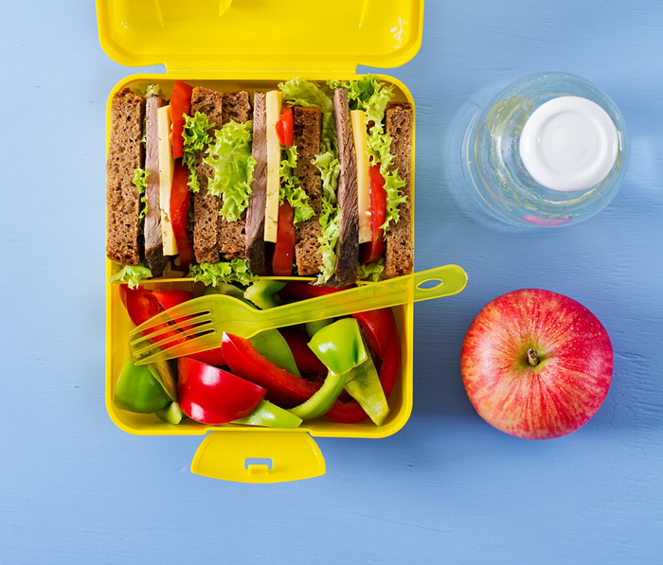

Name: ___________________________________________
Image: Designed by Freepik

Lesson 1: Healthy eating
- What do you know about the five food groups and healthy eating?
- What do you know about healthy lunchboxes?
- What would you like to know?

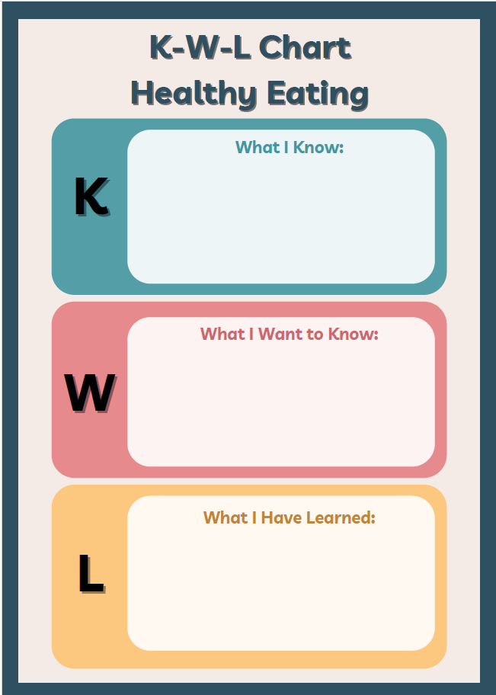

Lesson 1: Healthy eating
Include:
- foods from the five food groups
- at least 3 foods from each group.

Extension:
How are the foods in the food groups good for our bodies?

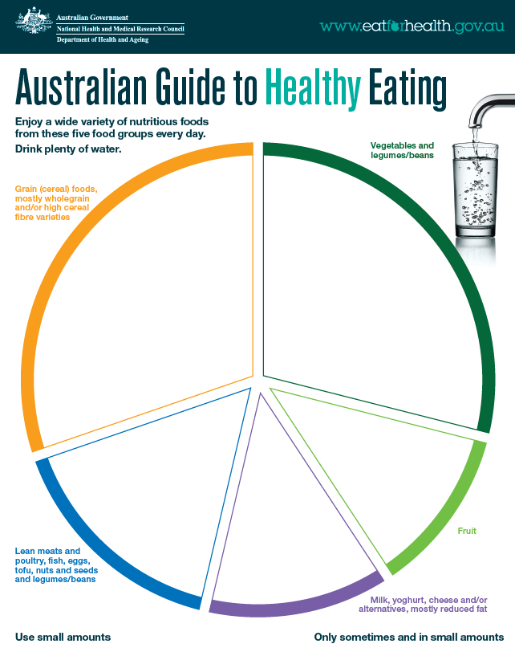
Source: National Health and Medical Research Council (representing the Commonwealth of Australia)

Lesson 3: Drawing and labelling a design
- Title
- Draw design
- Label each part

Draw and label a design of your choice.

Lesson 4: Healthy lunchbox snacks
- At least 3 items
- Label each item and its parts
- Label the food group/s in each item

Draw and label 3 healthy snacks for your lunchbox.

Lesson 5: Healthy lunch items
- At least 3 items
- Label each item and its parts
- Label the food groups in each item

Draw and label 3 healthy lunch items for your lunchbox.

Lesson 7: Making lunchbox items healthier

Suggest changes to make these lunchbox items healthier (modify foods or swap for something else). Label each image with your suggested changes.

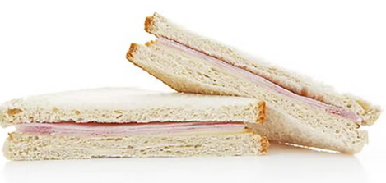
Ham sandwich on white bread

Lollies

Plain savoury biscuits

Potato crisps

Chocolate wafer bar

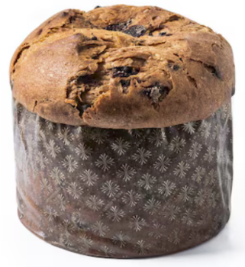
Chocolate muffin
Fruit drink (not 100% fruit juice)
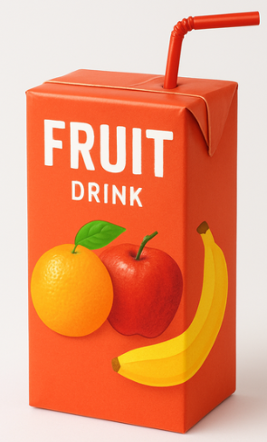
Chocolate chip biscuits
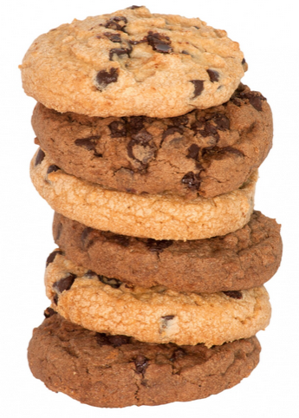
Images: Designed by Freepik and ChatGPT

Lesson 8: Summative assessment

Design brief for lunchbox design

Task: To design a healthy lunchbox. Explain how your lunchbox will help support health and wellbeing.

Format: You are to draw your lunchbox with the food and drink items.

Design criteria:

- Include:
- a fruit break snack
- recess item/s
- lunch item/s
- a drink
- your lunchbox must align with the Australian Guide to Healthy Eating (AGHE), including at least 3 of the AGHE food groups

Note: All items do not need to fit within a regular lunchbox. For example, a thermos can be used for some items.

On this drawing:

- Describe the key features (label your drawing).

- Explain how your lunchbox will help support health and wellbeing.

- Label the parts that meet the design criteria (above).

Checklist to assist with this assessment
Design feature | Tick when complete
Draw a lunchbox with a fruit break snack, recess item/s, lunch item/s, a drink
Lunchbox aligns with the AGHE and includes at least 3 of the AGHE food groups
Labelled with the key features (e.g. named each item)
Labelled to show how it meets the design criteria (identified the fruit break, recess, lunch, drink items AND the food groups).
Explained how the lunchbox will help support health and wellbeing (at least 2 reasons).

My healthy lunchbox

My lunchbox helps support health and wellbeing by:

Marking rubric

Criteria | Limited | Partial | Satisfactory | High | Outstanding
Criteria | The student
Lunchbox design (AS1 and 2) | Produces an outcome where most elements are missing from the representation of their lunchbox | Produces an outcome where some elements are missing from the representation of their lunchbox  Not all foods align with the AGHE AND/OR less than three food groups | Represents their lunchbox, through including the following:  - the required items (fruit break, recess, lunch, drink)  - mostly clear drawing and labelling  Foods align with the AGHE (3 food groups) | Represents their lunchbox with detail, through including the following:  - the required items (fruit break, recess, lunch, drink)  - clear drawing and labelling  Foods align with the AGHE (4 food groups) | Succinctly represents their lunchbox, through including the following:  - the required items (fruit break, recess, lunch, drink)  - very clear drawing and labelling  Foods align with the AGHE (5 food groups)
How lunchbox supports health and wellbeing (AS1) | Cannot identify how their lunchbox supports health and wellbeing | Provides minimal explanation of how their lunchbox will help support health and wellbeing (e.g. 1 example or examples are not clear) | Provides some explanation of how their lunchbox will help support health and wellbeing (e.g. 2 reasons) | Provides a clear explanation of how their lunchbox will help support health and wellbeing (e.g. 3 reasons) | Provides a detailed explanation of how their lunchbox will help support health and wellbeing (e.g. 4+ reasons)
Design criteria evaluation (AS3) | Cannot identify how their lunchbox aligns with the design criteria | Provides minimal detail on how their lunchbox design aligns with the design criteria | Provides a brief overview of how their lunchbox design aligns with the design criteria (e.g. basic detail and/or annotations) | Provides a clear overview of how their lunchbox design aligns with the design criteria (e.g. annotations addressing each of the design criteria and an assessment against the AGHE) | Provides a detailed overview of how their lunchbox design aligns with the design criteria (e.g. highly detailed annotations addressing each of the design criteria and an assessment against the AGHE)

