Food from plants and animals

Year 2
Student booklet
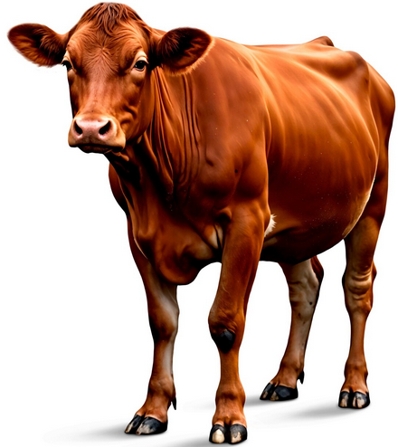
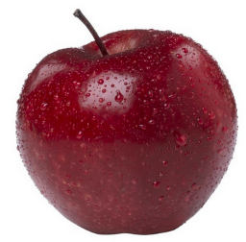

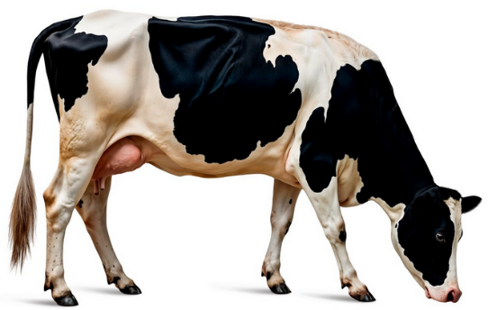
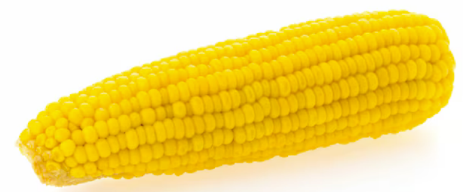

Name: ___________________________________________
Images: Designed by Freepik

Lesson 1: Where food comes from

- Where does our food come from?
- What categories of food can you think of?
- How does food get to the supermarket?
Draw pictures. Write words.

Lesson 2: Foods from plants and animals

Foods from plants | Foods from animals
Extension:
- Add additional foods
- What food groups do these foods belong to?

Lesson 3: From farm to the supermarket

Draw the steps (at least 3) that a food takes from a farm to the supermarket. Think about:
- where is the food is grown or reared?
- what happens to it at the farm?
- where does it go after the farm?
- what equipment is used?
- are there multiple steps and factories (for example, like bread, where flour is milled first, and then it is used to make bread)?

Lesson 4: Equipment and tools in food preparation

For each of the recipes below, identify:
- The tools and equipment needed to prepare the food
- The food groups in the recipe
- Whether the ingredients are from plants or animals
Baked beans on toast
Ingredients (4)  1 can baked beans  1 teaspoon margarine  2 slices wholemeal bread  1/3 cup grated cheese | Method  - Pour the baked beans into a microwave-safe bowl or mug.  - Cover loosely with a microwave-safe lid or paper towel (to prevent splatters).  - Microwave on high for 1½ to 2 minutes, stirring halfway through.  - Toast the bread slices in a toaster until golden.  - Spread margarine over the toast.  - Spoon the hot baked beans over the toast.  - Sprinkle with grated cheese.

Tools and equipment | Food groups | Foods from plants/ animals

Vegetables and hummus (store bought hummus)
Ingredients (3)  1 carrot  1 baby cucumber  1/4 cup store-bought hummus | Method  - Peel the carrot and cut into sticks (about 10 cm long).  - Cut the cucumber into sticks (about 10 cm long).  - Place the hummus into a small bowl. Serve with the vegetables.

Tools and equipment | Food groups | Foods from plants/ animals

Can you create your own:
Ingredients | Method

Tools and equipment | Food groups | Foods from plants/ animals

Lesson 5: Drawing and labelling foods

Draw a prepared food item that aligns with Australian Guide to Healthy Eating.
Include:
- Title
- Label the image:
- The tools and equipment needed to prepare the food
- The food groups in the recipe
- Whether the ingredients are from plants or animals

Lesson 6: Designing a healthy snack

- Draw a healthy snack based on the Australian Guide to Healthy Eating.
- Label your snack with the ingredients.
Extension:
Label with:
- The tools and equipment needed to prepare the food
- The food groups in the recipe
- Whether the ingredients are from plants or animals

Lesson 7: Sensory evaluation

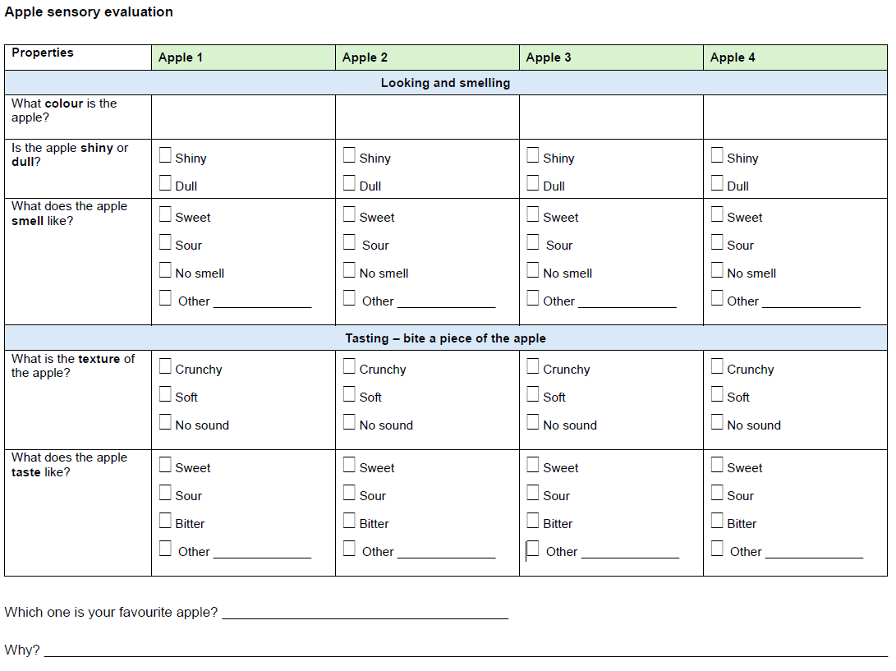

Lesson 8: Summative assessment

Design brief for snack

Task: To design a healthy snack. Explain how the Australian Guide to Healthy Eating helped guide the design of your snack.

Format: You are to draw your healthy snack.

Design criteria:

- Include at least 2 of the AGHE food groups.

On this drawing:

- Label your drawing, with information that shows:
- the source of ingredients – the parts that are from plant and animals
- what tools and equipment you would need to prepare your snack
- what food groups are included.

- Explain how the AGHE helped guide the design of your snack (at least 2 ways).

Checklist to assist with this assessment
Design feature | Tick when complete
Draw a healthy snack with at least 2 food groups

Label with the source of ingredients (parts from plants and animals)
Label with the tools and equipment needed to prepare the snack
Label with the food groups that are included

Explain how the AGHE was used to help guide the design of this snack (at least 2 ways)

My healthy snack
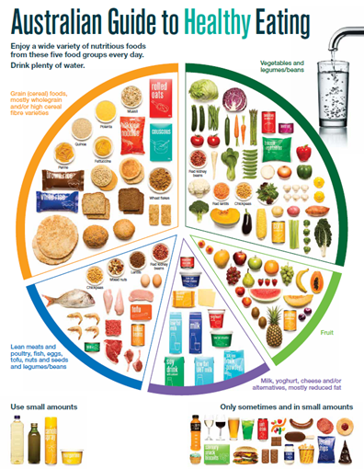

How did the Australian Guide to Healthy Eating help guide the design of your snack?

Marking rubric

Criteria | Limited | Partial | Satisfactory | High | Outstanding
Criteria | The student
Snack design (AS1 and AS2) | Produces an outcome where most elements are missing from the representation of their snack | Produces an outcome where some elements are missing from the representation of their snack | Designs a snack that includes 2 foods groups  Includes some information on source of ingredients (animals, plants), tools and equipment to prepare snack, food groups. | Designs a snack that includes 3 foods groups  Includes clear information on source of ingredients (animals, plants), tools and equipment to prepare snack, food groups. | Designs a snack that includes 4+ foods groups  Includes detailed information on source of ingredients (animals, plants), tools and equipment to prepare snack, food groups.
Using health information (AS3) | Cannot identify how the AGHE helped with the design of their snack | Provides minimal explanation of how the AGHE helped with the design of their snack (e.g. 1 way or their explanation is not clear) | Provides some explanation of how the AGHE helped with the design of their snack (e.g. 2 ways) | Provides a clear explanation of how the AGHE helped with the design of their snack (e.g. 3 ways) | Provides a detailed explanation of how the AGHE helped with the design of their snack (e.g. 4+ ways)

