Designing food for consumers, the environment and healthy eating

Year 10
Student booklet
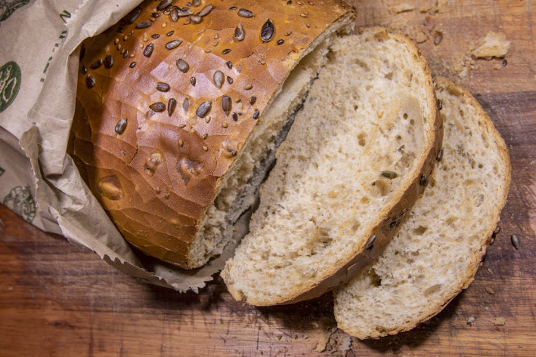
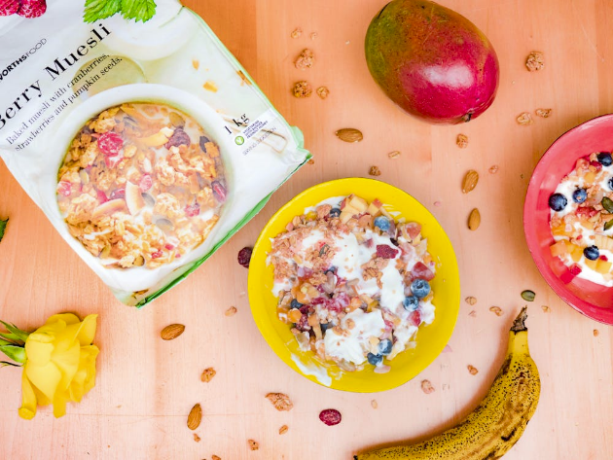

Name: ___________________________________________
Images: Designed by Pexels

Lesson 1: Food groups: packaged foods

Identify at least 3 packaged food that can be included in each of the food groups.
Food group | Foods
Grain foods
Fruit
Vegetables
Meat and alternatives
Dairy and alternatives

Lesson 2: Food processing and healthy eating

- Identify a packaged food product that helps consumers eat a healthy diet.
- Identify and describe the nutritious components of the food.
- Identify whether the nutritional quality of the product could be improved.

Packaged food:

Summary of nutritious components of the food (link to the Australian Guide to Healthy Eating)

Suggested changes to improve the nutritional quality of the food

Lesson 3: Product development

For each of the product development categories, identify current products and specify the benefits to consumers. Consider aspects such as:
- nutrition
- shelf-life
- convenience
- sensory (taste, texture, smell, appearance)

Line extension
Product | Changes from original | Consumer benefits

New to world
Product | Unique features | Consumer benefits

Me-too
Product | Product being copied | Consumer benefits

Lesson 4: Product evaluation

- Choose 3 food products.
- Evaluate these products based on the 5 senses (tick all that apply in each category)
- Compare results (results across own foods, and how rating compares with a peer)
Food product 1:
Appearance |  |  | Taste |  |  | Smell |  |  | Texture
☐ Dry  ☐ Moist  ☐ Runny  ☐ Mushy  ☐ Flaky  ☐ Soft  ☐ Rough  ☐ Rustic  ☐ Colourful | ☐ Fluffy  ☐ Crumbly  ☐ Fizzy  ☐ Lumpy  ☐ Hard  ☐ Flat  ☐ Smooth  ☐ Round  ☐ Dull |  | ☐ Sweet  ☐ Salty  ☐ Mild  ☐ Bitter  ☐ Sour  ☐ Umami  ☐ Zesty  ☐ Sharp  ☐ Bland | ☐ Tart  ☐ Spicy  ☐ Rich  ☐ Tangy  ☐ Acidic  ☐ Fruity  ☐ Strong  ☐ Weak  ☐ Savoury |  | ☐ Aromatic  ☐ Floral  ☐ Rotten  ☐ Spicy  ☐ Sweet  ☐ Bland  ☐ Rotten  ☐ Pungent  ☐ Tart |  | ☐ Mild  ☐ Strong  ☐ Herby  ☐ Fishy  ☐ Fresh  ☐ Cheesy  ☐ Musty  ☐ Scented  ☐ Spoiled | ☐ Brittle  ☐ Mushy  ☐ Lumpy  ☐ Smooth  ☐ Rubbery  ☐ Tender  ☐ Sticky  ☐ Crumbly  ☐ Crisp |  | ☐ Soft  ☐ Dry  ☐ Hard  ☐ Gritty  ☐ Chewy  ☐ Creamy  ☐ Moist  ☐ Slimy  ☐ Fluffy
Rate the product using the scale below:
I don’t like it at all  ☐ 1 |  | I dislike it slightly  ☐ 2 |  |  | I neither like or dislike it  ☐ 3 |  | I like it slightly  ☐ 4 |  |  | I like it a lot  ☐ 5
How could the product be improved so you would like it more?

Food product 2:
Appearance |  |  | Taste |  |  | Smell |  |  | Texture
☐ Dry  ☐ Moist  ☐ Runny  ☐ Mushy  ☐ Flaky  ☐ Soft  ☐ Rough  ☐ Rustic  ☐ Colourful | ☐ Fluffy  ☐ Crumbly  ☐ Fizzy  ☐ Lumpy  ☐ Hard  ☐ Flat  ☐ Smooth  ☐ Round  ☐ Dull |  | ☐ Sweet  ☐ Salty  ☐ Mild  ☐ Bitter  ☐ Sour  ☐ Umami  ☐ Zesty  ☐ Sharp  ☐ Bland | ☐ Tart  ☐ Spicy  ☐ Rich  ☐ Tangy  ☐ Acidic  ☐ Fruity  ☐ Strong  ☐ Weak  ☐ Savoury |  | ☐ Aromatic  ☐ Floral  ☐ Rotten  ☐ Spicy  ☐ Sweet  ☐ Bland  ☐ Rotten  ☐ Pungent  ☐ Tart |  | ☐ Mild  ☐ Strong  ☐ Herby  ☐ Fishy  ☐ Fresh  ☐ Cheesy  ☐ Musty  ☐ Scented  ☐ Spoiled | ☐ Brittle  ☐ Mushy  ☐ Lumpy  ☐ Smooth  ☐ Rubbery  ☐ Tender  ☐ Sticky  ☐ Crumbly  ☐ Crisp |  | ☐ Soft  ☐ Dry  ☐ Hard  ☐ Gritty  ☐ Chewy  ☐ Creamy  ☐ Moist  ☐ Slimy  ☐ Fluffy
Rate the product using the scale below:
I don’t like it at all  ☐ 1 |  | I dislike it slightly  ☐ 2 |  |  | I neither like or dislike it  ☐ 3 |  | I like it slightly  ☐ 4 |  |  | I like it a lot  ☐ 5
How could the product be improved so you would like it more?

Food product 3:
Appearance |  |  | Taste |  |  | Smell |  |  | Texture
☐ Dry  ☐ Moist  ☐ Runny  ☐ Mushy  ☐ Flaky  ☐ Soft  ☐ Rough  ☐ Rustic  ☐ Colourful | ☐ Fluffy  ☐ Crumbly  ☐ Fizzy  ☐ Lumpy  ☐ Hard  ☐ Flat  ☐ Smooth  ☐ Round  ☐ Dull |  | ☐ Sweet  ☐ Salty  ☐ Mild  ☐ Bitter  ☐ Sour  ☐ Umami  ☐ Zesty  ☐ Sharp  ☐ Bland | ☐ Tart  ☐ Spicy  ☐ Rich  ☐ Tangy  ☐ Acidic  ☐ Fruity  ☐ Strong  ☐ Weak  ☐ Savoury |  | ☐ Aromatic  ☐ Floral  ☐ Rotten  ☐ Spicy  ☐ Sweet  ☐ Bland  ☐ Rotten  ☐ Pungent  ☐ Tart |  | ☐ Mild  ☐ Strong  ☐ Herby  ☐ Fishy  ☐ Fresh  ☐ Cheesy  ☐ Musty  ☐ Scented  ☐ Spoiled | ☐ Brittle  ☐ Mushy  ☐ Lumpy  ☐ Smooth  ☐ Rubbery  ☐ Tender  ☐ Sticky  ☐ Crumbly  ☐ Crisp |  | ☐ Soft  ☐ Dry  ☐ Hard  ☐ Gritty  ☐ Chewy  ☐ Creamy  ☐ Moist  ☐ Slimy  ☐ Fluffy
Rate the product using the scale below:
I don’t like it at all  ☐ 1 |  | I dislike it slightly  ☐ 2 |  |  | I neither like or dislike it  ☐ 3 |  | I like it slightly  ☐ 4 |  |  | I like it a lot  ☐ 5
How could the product be improved so you would like it more?

Lesson 5: Food production and the environment

Identify key environmental issues related to:
- growing food in Australia
- processing food in Australia.
Identify how technology can help reduce the environmental impact of food production.
Growing food (farming)
Environmental issues
How technology can reduce environmental impact

Producing food (food manufacturing)
Environmental issues
How technology can reduce environmental impact

Lesson 6: Food packaging and the environment

- Identify key factors or strategies that can help reduce the environmental impact of food packaging.
- Consider the entire food packaging chain (production, consumer behaviour, recycling).
- Consider the role of industry, government and consumers.
Use the video from this lesson and conduct your own research.

Lesson 7, 8 and 9: Summative assessment

Designing food for healthy eating

Task: To design a packaged food product that meets the needs of consumers, considers environmental issues, and assists with enhancing healthy eating.

Format: You have the choice of how to present your food product design e.g. written, poster, Word, PowerPoint. It does not need to be a text heavy piece, and be sure to include images to complement and support your design.

Criteria: Your food must be considered a core food within the Australian Guide to Healthy Eating (or a combination of core foods).

Include the following information:
- Introduction (about the food product).
- Pictorial representation of the food product.
- Description of how the product meets the needs of consumers.
- Description of how the food considers environmental issues (production and disposal).
- Description of how the food assists with enhancing healthy eating.

Your product can either be ‘new to world’ or a ‘line extension’ (modifications to a current food product).

Use the information gathered throughout the unit to assist with generating ideas for the food product.

Task text checklist (modify or re-design as needed)

Criteria | Tick when complete
Food selected is a core food within the AGHE (or a combination)
Introduction

Pictorial representation of the food product

Description of how the product meets the needs of consumers
Description of how the food considers environmental issues (production and disposal)
Description of how the food assists with enhancing healthy eating

Marking rubric

Criteria | Limited | Partial | Satisfactory | High | Outstanding
Criteria | The student
Food product (AS1 and AS2) | Selects a food that is not a core food within the Australian Guide to Healthy Eating  Most elements are missing from their product overview | Selects a food that is not a core food within the Australian Guide to Healthy Eating  Includes an overview of consumer and environmental considerations; however, the information is not clear and/ or is incorrect  Image is lacking in design and/or detail | Selects a food that is a core food within the Australian Guide to Healthy Eating  Includes a basic overview of consumer and environmental considerations (e.g. 1 piece of information in each area)  Includes a basic pictorial representation | Selects a food that is a core food within the Australian Guide to Healthy Eating  Includes a clear overview of consumer and environmental considerations (e.g. 2 pieces of information in each area)  Includes a clear pictorial representation | Selects a food that is a core food within the Australian Guide to Healthy Eating  Includes a detailed overview of consumer and environmental considerations (e.g. 3+ pieces of information in each area)  Includes a detailed pictorial representation
Synthesising health information (AS3) | Cannot identify how the food is important to assist with healthy eating | Provides minimal information on how the food is important to assist with healthy eating (e.g. 1 reason or their reasons are incorrect or not clear) | Provides some information on how the food is important to assist with healthy eating (e.g. 2 reasons) | Provides clear information on how the food is important to assist with healthy eating (e.g. 3 reasons) | Provides detailed information on how the food is important to assist with healthy eating (e.g. 4+ reasons)

